Course Title: AI-Assisted Coding
Batch – 05
Hall no. – 2303A51305
Question: Lab 1: Environment Setup – GitHub Copilot and VS Code Integration + Understanding AI-assisted Coding Workflow
Task 0 ● Install and configure GitHub Copilot in VS Code. Take screenshots of each step.
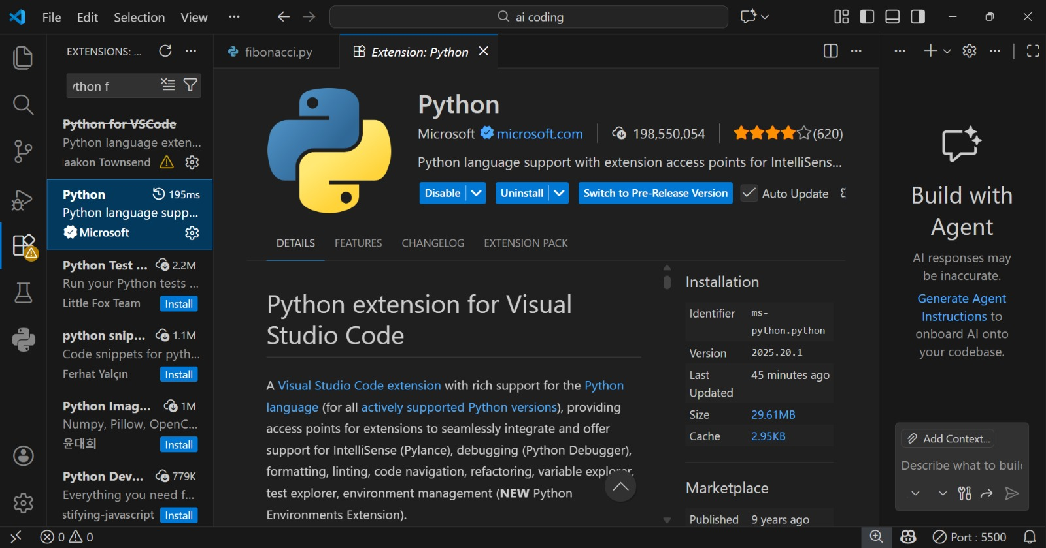
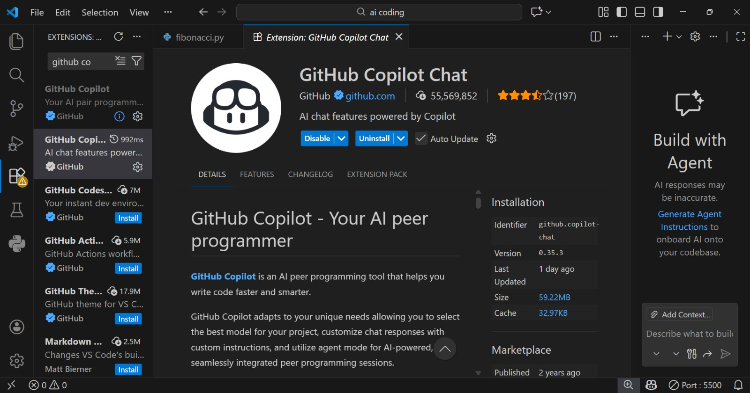

Task 1: AI-Generated Logic Without Modularisation (Fibonacci Sequence Without Functions)
Input :

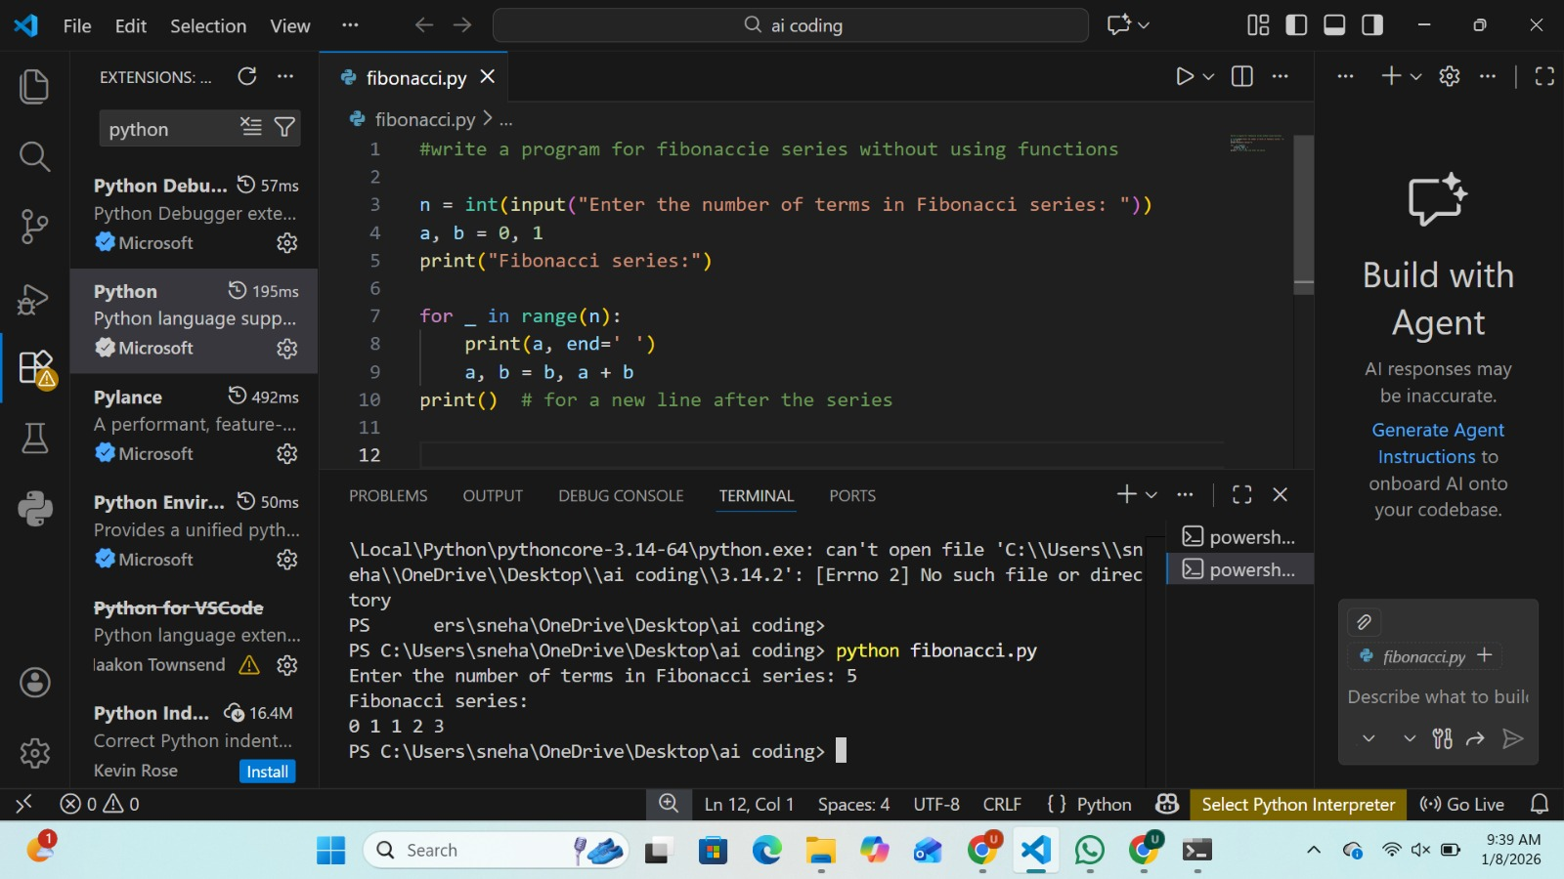
Output :

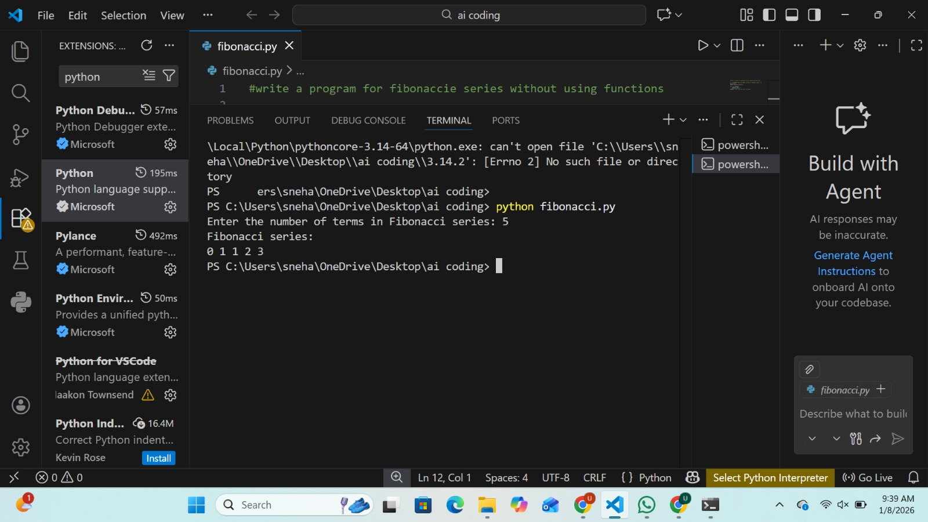

Task 2: AI-Code Optimisation & Cleanup (Improving Efficiency)
Input :

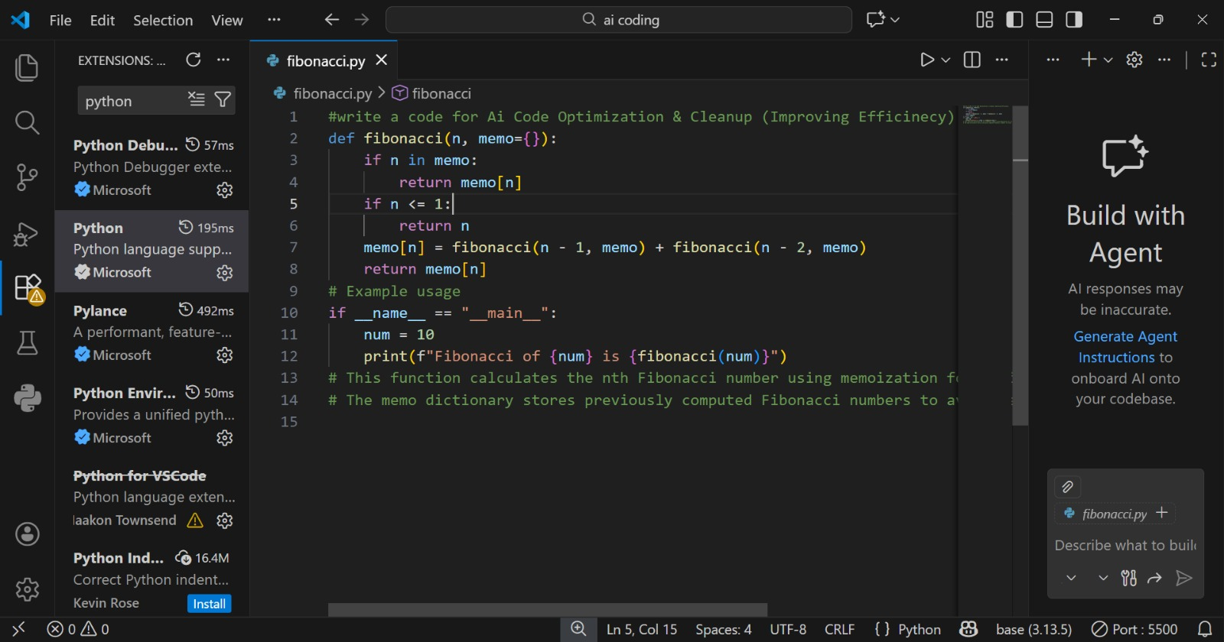
Output :

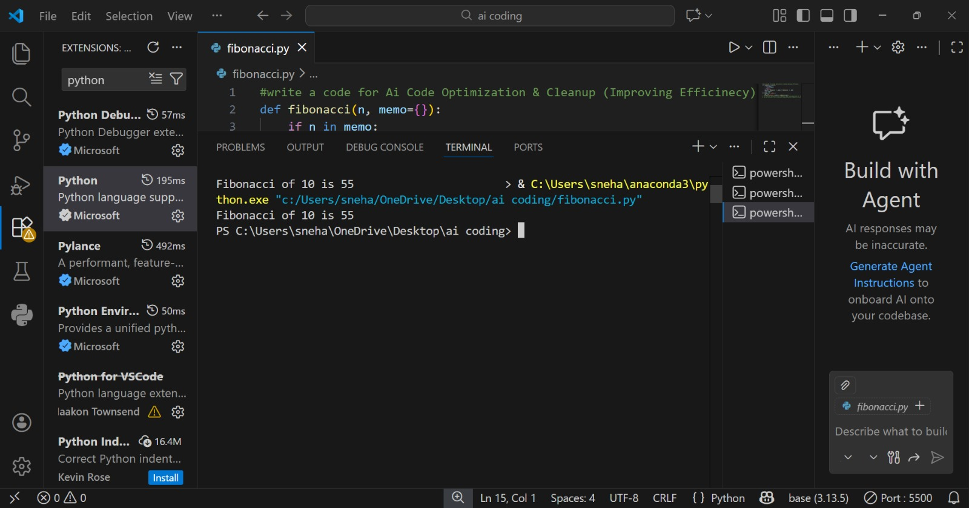

Task 3: Modular Design Using AI Assistance (Fibonacci Using Functions)
Input :

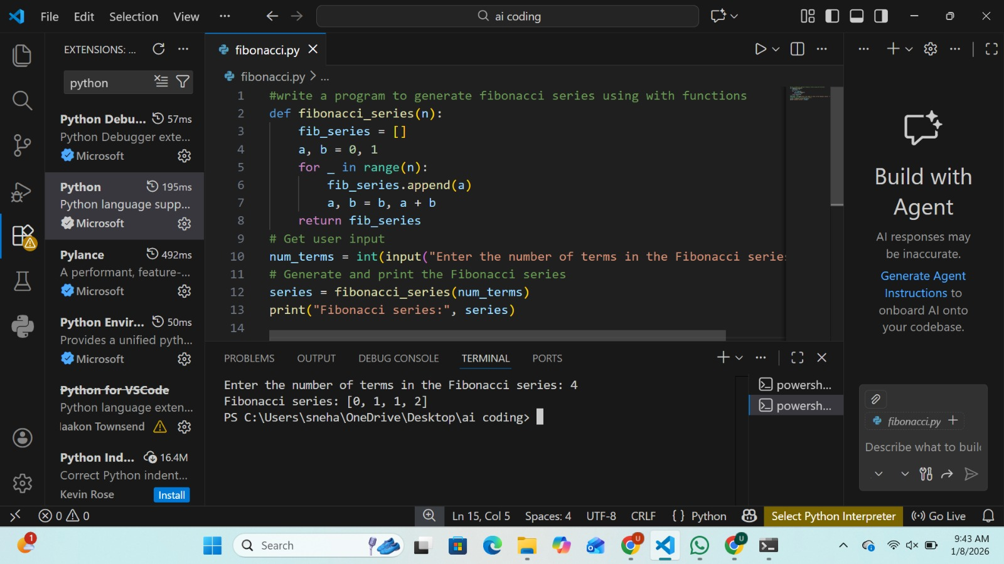
Output :

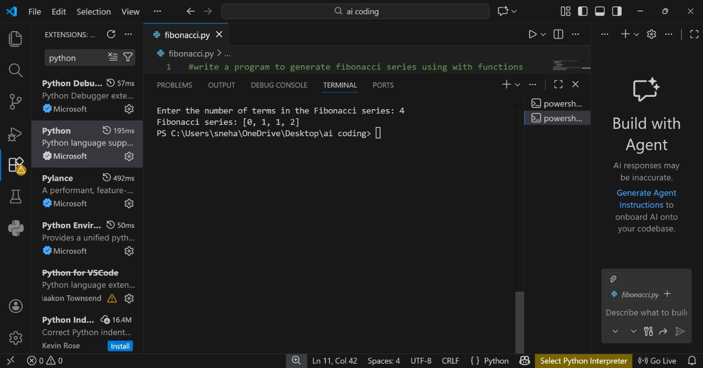

Task 4: Comparative Analysis – Procedural vs Modular Fibonacci Code
Input :

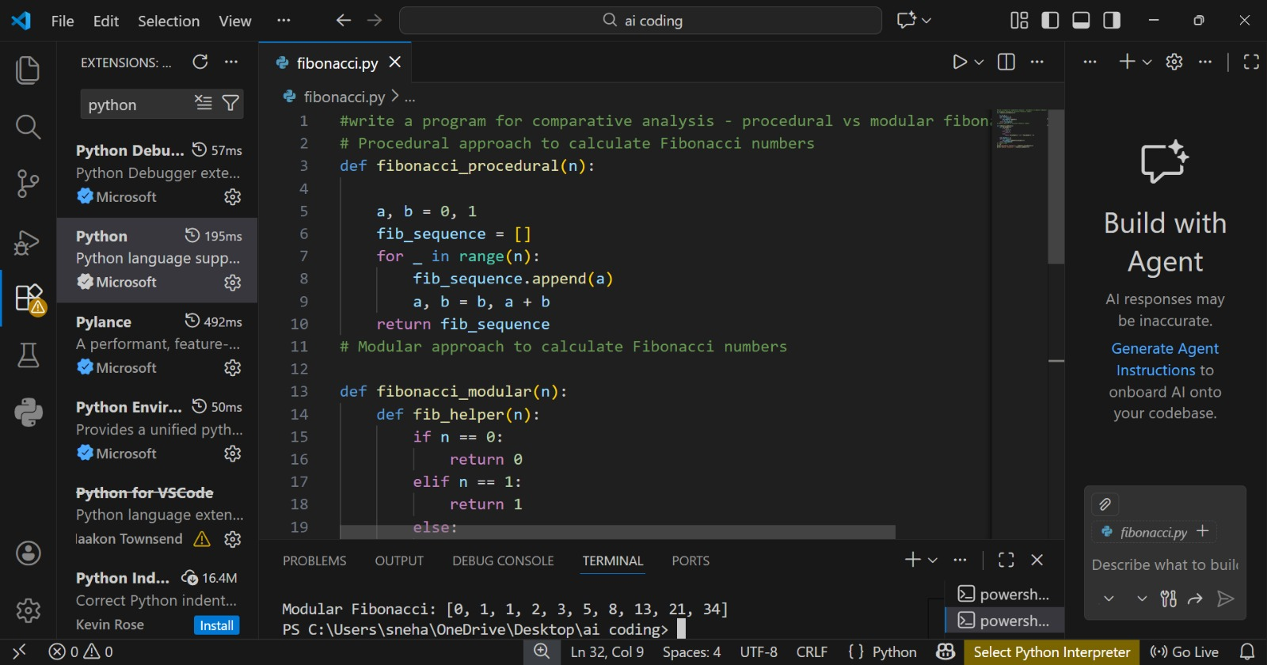

Output :

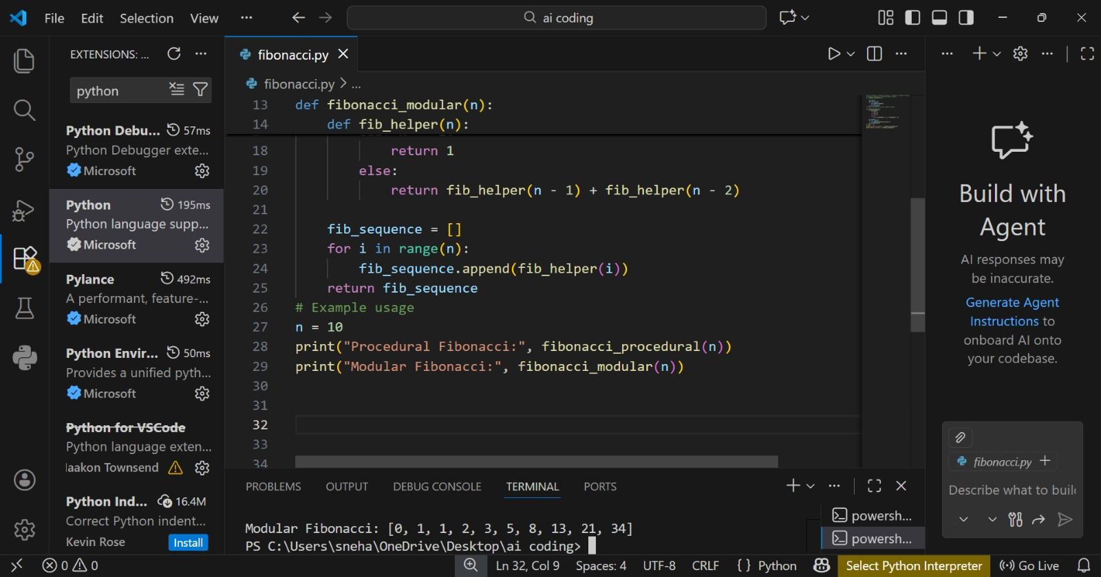

Task 5: AI-Generated Iterative vs Recursive Fibonacci Approaches (Different Algorithmic Approaches for Fibonacci Series)
Input :
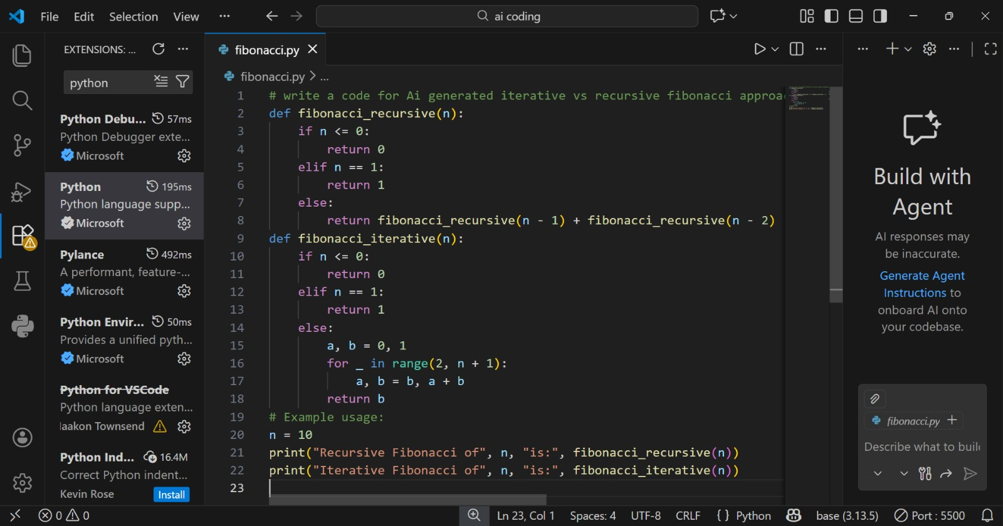

Output :

